Project Documentation

PROJECT TITLE: FITFLEX: Your personal fitness companion

Screenshots

# 

# Hero component

# 

# About

# Search

# Category page

# Exercise page

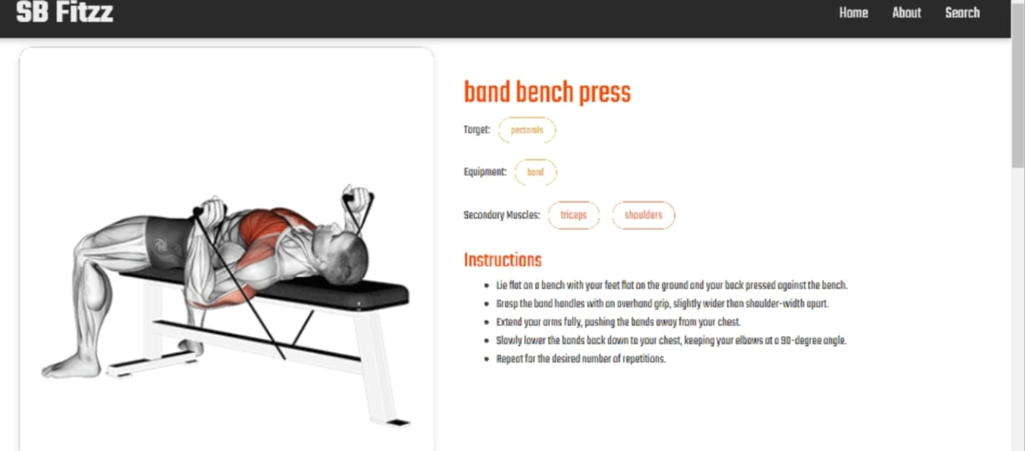

* **Related videos on YouTube**

